Placement Percentile Report

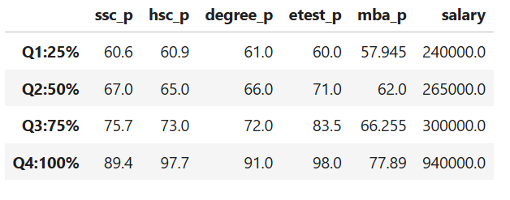
SSC Percentage (ssc_p)
Q1 to Q2 (60.6 → 67.0):
Scores increased by 6.4 percentage points, showing a moderate change in performance.
Q2 to Q3 (67.0 → 75.7):
Scores increased by 8.7 percentage points, showing a moderate change in performance.
Q3 to Q4 (75.7 → 89.4):
Scores increased by 13.7 percentage points, showing a higher change in performance.
HSC Percentage (hsc_p)
Q1 to Q2 (60.9 → 65.0):
Scores increased by 4.1 percentage points, showing a lower change in performance.
Q2 to Q3 (65.0 → 73.0):
Scores increased by 8.0 percentage points, showing a moderate change in performance.
Q3 to Q4 (73.0 → 97.7):
Scores increased by 24.7 percentage points, showing a moderate change in performance. Degree Percentage (degree_p)
Q1 to Q2 (61.0 → 66.0):
Scores increased by 5.0 percentage points, showing a lower change in performance.
Q2 to Q3 (66.0 → 72.0):
Scores increased by 6.0 percentage points, showing a moderate change in performance.
Q3 to Q4 (72.0 → 91.0):
Scores increased by 19.0 percentage points, showing a higher change in performance.
Entrance Test Percentage (etest_p)
Q1 to Q2 (60.0 → 71.0):
Scores increased by 11.0 percentage points, showing a higher change in performance.
Q2 to Q3 (71.0 → 83.5):
Scores increased by 12.5 percentage points, showing a higher change in performance.
Q3 to Q4 (83.5 → 98.0):
Scores increased by 14.5 percentage points, showing a higher change in performance.
MBA Percentage (mba_p)
Q1 to Q2 (57.95 → 62.0):
Scores increased by 4.05 percentage points, showing a lower change in performance.
Q2 to Q3 (62.0 → 66.26):
Scores increased by 4.26 percentage points, showing a lower change in performance.
Q3 to Q4 (66.26 → 77.89):
Scores increased by 11.63 percentage points, showing a higher change in performance.
Salary
Q1 to Q2 (₹2,40,000 → ₹2,65,000):
Salary increased by ₹25,000, showing a lower change in salary.
Q2 to Q3 (₹2,65,000 → ₹3,00,000):
Salary increased by ₹35,000, showing a moderate change in salary.
Q3 to Q4 (₹3,00,000 → ₹9,40,000):
Salary increased by ₹6,40,000, showing a higher change in salary.

